**LAB-1**

1. Created a project named RetailInventory

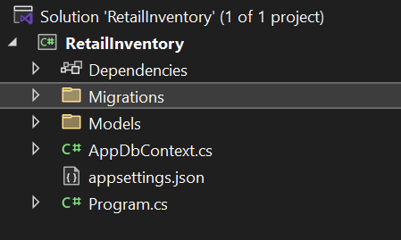

1. Installed required packages

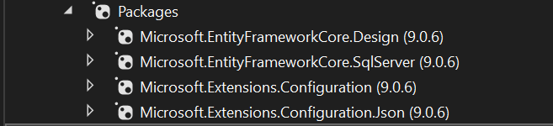

**LAB-2**

1. **Category.cs**

namespace RetailInventory.Models

{

public class Category

{

public int Id { get; set; }

public string Name { get; set; }

public List<Product> Products { get; set; }

}

}

**Product.cs**

using System;

using System.Collections.Generic;

namespace RetailInventory.Models

{

public class Product

{

public int Id { get; set; }

public string Name { get; set; }

public decimal Price { get; set; }

public int CategoryId { get; set; }

public Category Category { get; set; } // ✅ This should now work

}

}

1. **AppDbContext.cs**

using Microsoft.EntityFrameworkCore;

using Microsoft.Extensions.Configuration;

using RetailInventory.Models;

public class AppDbContext : DbContext

{

public DbSet<Product> Products { get; set; }

public DbSet<Category> Categories { get; set; }

protected override void OnConfiguring(DbContextOptionsBuilder optionsBuilder)

{

var config = new ConfigurationBuilder()

.SetBasePath(Directory.GetCurrentDirectory())

.AddJsonFile("appsettings.json")

.Build();

optionsBuilder.UseSqlServer(config.GetConnectionString("DefaultConnection"));

}

}

1. **appsettings.json**

{

"ConnectionStrings": {

"DefaultConnection": "Server=(localdb)\\MSSQLLocalDB;Database=RetailInventoryDb;Trusted_Connection=True;TrustServerCertificate=True;"

}

}

**LAB-3**

1. Created initial migration



1. Apply migration to create database

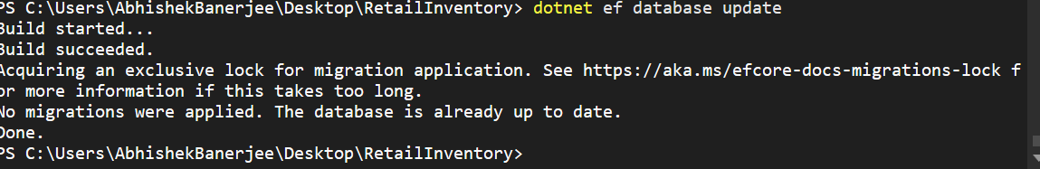

1. Table in MS SQL server

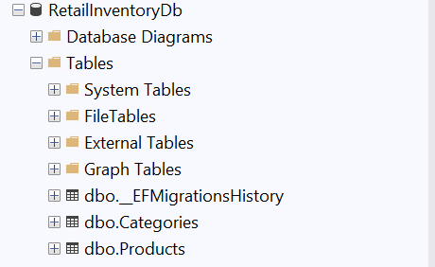

**LAB-4**

**Program.cs**

using RetailInventory.Models;

using System;

using System.Threading.Tasks;

class Program

{

static async Task Main(string[] args)

{

using var context = new AppDbContext();

// Create categories

var electronics = new Category { Name = "Electronics" };

var groceries = new Category { Name = "Groceries" };

await context.Categories.AddRangeAsync(electronics, groceries);

// Create products

var product1 = new Product

{

Name = "Laptop",

Price = 75000,

Category = electronics

};

var product2 = new Product

{

Name = "Rice Bag",

Price = 1200,

Category = groceries

};

await context.Products.AddRangeAsync(product1, product2);

await context.SaveChangesAsync();

Console.WriteLine("Data inserted successfully.");

}

}

**Categories table updated**

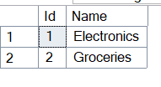

**Product Table**

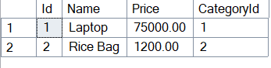

**LAB-5**

1. **Retrieve all Products**

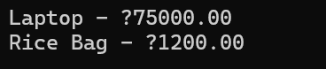

**2)Retrieve Product by ID**



1. **FirstOrDefault with condition**

